**The minutes of a committee meeting held at the school on Friday 7 October, 2016**

**Members present**: P. Lusted (in the chair), S. Caveney, D. Palmer, K. Shea,

P. Taylor, M. Pack, C. Laming, M. Stewart, N. Hancock, I. Hazell, T. Saunders.

**Apologies for absence**: G. Barnes, B. Gilbert, A. Snelling.

**Minutes and matters arising**: The minutes of the meeting held on Friday 2 October, 2015, were agreed and signed as a correct record.

**Correspondence**: None.

**Football report:** The new season has started and much like all the other seasons we anticipate a slow start especially as our goalkeeper for the past 6 years has retired and we haven’t replaced him. Instead we are taking it in turns in goal until we find the one who is least useless; mind you it could be worse, we could have Joe Hart in goal.

However, the use of stunt goalkeepers is paying off, as we are top of the table after 4 games, 3 wins and 1 defeat, so it seems that our previously appalling league form is down to our bespectacled ex- goalkeeper. Maybe we should have suspected something when he followed the walls around the pitch to reach his goal. Half time changeovers took ages.

This early season form won’t last of course but it makes a pleasant change.

The lack of suitable venues for the Sittingbourne Indoor 5-a-side League has meant that we again have the 9.00PM – 10.30PM slot on Wednesdays but that only put one team off (Oz Clark 5 and they won everything last season so we’re not sorry to see them go) however, two new teams have joined so there are now seven teams. That will make for interesting cup draws but it also provides more variety in the league so it’s no bad thing.

We have added one new player, Dave Collins, who we poached from Oz Clark 5 and he has made a difference to our performances and, even better, he is an Old Bordenian too.

Last season we finished in fifth place as you will see from the final table below but 4th was on the cards until we lost our final game against St Michaels.

|  |  |  |  |  |  |  |  |
| --- | --- | --- | --- | --- | --- | --- | --- |
|  | **Played** | **Won** | **Drawn** | **Scored** | **Against** | **GD** | **Points** |
| Oz Clarke 5 | 30 | 26 | 3 | 100 | 13 | +87 | 81 |
| Kestrels 2 | 30 | 19 | 3 | 47 | 22 | +25 | 60 |
| Faversham 2 | 30 | 15 | 4 | 47 | 40 | +7 | 49 |
| St Michaels | 30 | 9 | 3 | 33 | 59 | -26 | 30 |
| Old Bordenians | 30 | 6 | 8 | 33 | 55 | -22 | 26 |
| Faversham | 30 | 3 | 3 | 14 | 85 | -71 | 12 |

Again we had more success in the cups and won two runners-up medals in the Consolation Cup and in the Charity Cup. At this rate Peter Thomson will have to add an extension to his trophy cabinet.

This year’s squad is: Peter Thomson, Cliff Cork, Jon Cork, Julian Cork, Simon Thomson, Gary Johnson, James Thingamy, Dave Collins and Keith Shea.

Many thanks to our ex goalkeeper Aida who really will be sorely missed.

So we desperately need a goalkeeper, one with his own gloves would be the icing on the cake and if they turn out to be goalkeeping gloves that would be the cherry on the top.

If that’s you please get in touch with me at [toshea@live.co.uk](mailto:toshea@live.co.uk)

One last point: The first of hopefully many reunions of the Old Bordenians Football Club was held on 31st March 2016 and you can see a report on the Old Bordenians website

**Keith Shea, Football secretary**

**Hockey report:** The following report was provided by Alan Wilson, Chairman of OBHC:

*1. There have been some important developments as regards the men's 1st X1.*

*For some years, Old Boys men's 1st X1 have resided in Kent/Sussex Division 1, mostly, but not always, in the top half of the table, and, last season finishing fourth. As part of the usual end of season/pre-season review of the Club, it was clear that, although we were, overall, pleased with the 2015/2016 results of the men's 1st X1, we remained convinced that, with the addition of a couple of strong players, and a sound plan, we are quite capable of playing at a higher level.*

*We were aware of two players who were giving consideration to a change of club and discussions ensued. The result is that Tom Richford, who has played in the National Premier League for Canterbury for some years, and who was last year, and for several previous seasons, their 1st X1 captain, has decided to join Old Bordenian HC. Tom is a player of high quality and brings a wealth of experience. Sam Lund, an Old Bordenian who, for family reasons, has played at Holcombe HC, at the top level, since leaving Borden, also has joined us.*

*The former Canterbury HC men's 1st X1 coaching team of Kwan Browne and Huw Stevens have moved to National Premier club Hampstead and Westminster and, having shared our thoughts and plan with Huw, we are pleased to report that he has committed to coach also at Old Bordenian HC. Huw is a highly respected and experienced coach who will bring much to our club.*

*The need for a 1st X1 manager was identified some seasons ago but no suitable candidate was available. Bob Foster, a former OBHC 1st X1 player, has agreed to take on that role. With James Henley as captain and Richard Ford and Iain Burwood as co-vice-captains, the management structure is sound and experienced. The Club has high hopes for success for this season and beyond.*

*The Ladies 1st X1 management remains in the capable hands of Sanj Atwal as coach, Jo Wilson as captain and Jackie Woodhouse as vice-captain. Katie Lovelock, having taken a season's sabbatical in order to give birth, returns for the 2016/2017 season, and three new players have joined the club over the summer break.*

*In order to attract new players, the Club will run several Back To Hockey sessions in September which are aimed at men and ladies who used to play but, for whatever reasons, have stopped, and at any men and ladies who just want to give the sport a try. Anyone interested should email info@obhc.co.uk and go to the Club's website (www.obhc.co.uk) for details.*

*The Club continues to run 6 men's teams and 2 ladies teams, U14s, U16s and coaching for minis age 5 – 11.*

*Old Bordenian HC continues to host and manage, on behalf of Kent Hockey Association, the Swale Junior Development Centre and the Kent U13 boys Junior Academy Centre.*

*The artificial grass pitch at the School, owned jointly by Old Bordenian HC and Borden Grammar School, is in need of a replacement surface. The estimated cost of that project is £200,000+VAT and it is hoped that the work will take place in the summer of 2017. Competition for funding from bodies such as Sport England and others is intense and the club/school partnership must demonstrate that it will commit significant funding of its own to the project. Donations, of any amount, will be greatly appreciated and will strengthen the case for applications to potential funders. If you can consider making a donation, please email* [*info@obhc.co.uk*](mailto:info@obhc.co.uk) *to find out how to do it. This project is vital to the future of the excellent artificial grass facility which the Club and School are very fortunate to possess.*

1. The final 2015/16 league positions of the respective teams is as follows:
   * Men’s1st X1 – Kent / Sussex Regional League Division 1 – 4th
   * Men’s 2nd X1 – Kent Area League Division 1 – 5th (following promotion last year)
   * Men’s3rd X1 – Kent Area League Division 2 – 11th (relegated to Kent Open Premier A, following promotion last year)
   * Men’s 4th XI - Kent Open Premier C – 10th
   * Men’s 5th XI – Kent Open Division 2 – 8th
   * Men’s 6th XI – Kent Open Division 3 – 10th
   * Ladies 1st XI – Kent Women’s Premier Division – 3rd
   * Ladies 2nd XI – Kent Women’s Division 4 – 10th (following promotion last year)

**David Palmer, OBA Hockey Representative**

**Website report:**

**1 We continue to add articles to the website when they are received from members, although these continue to be few and far between! To supplement this input, we have added a number of old GCE ‘O’ and ‘A’ level papers to coincide with the exam season in May / June and also have started to add previous Maroon magazines to ensure they are readily available to all. Where possible, the contents of each of the magazines are listed on the website to ensure they are searchable, using the site’s search facility.**

1. **During the year, the Website team decided to email all OBA members whenever a new article was added to the website, provided we didn’t inundate members with emails. This ensured members were aware of new postings immediately, without the need to keep checking the site. Members were able to opt out of these information emails, with one member taking advantage of this opt out. The ability to opt out of website update emails is included in every email sent out, in line with bulk emailing etiquette.**
2. **Annex A shows the additions since last year’s AGM, together with their date of posting and number of hits to 28th August 2016. For information, I have also added, at Annex B, a table showing those postings with the most hits since the new site went live in January 2013.**
3. **As noted above, few articles are received from OBA members. To enhance the usefulness of the site and make it more appealing to fellow Old Bordenians, it would be appreciated if members would consider producing something of interest to post on the website. Any such articles should be emailed to** [**webmaster@oldbordenians.co.uk**](mailto:webmaster@oldbordenians.co.uk)**.**
4. **The website continues to be reasonably stable. There was a short period during Spring 2016 when the school site (host of the OBA website) was hit by a virus and the site was unavailable for a short period. However, during this time, the school IT technician took the opportunity to upgrade the hosting system to the latest versions of software. At my request, a ‘Search’ facility was also added. This can be found at the top right hand side of the website. We continue to be grateful to the school for providing the hosting capability for the website to reduce our annual costs. This in turn allows us to provide more money to school projects.**
5. **A Website Digest, containing all articles published in 2015 was produced and posted to those OBA members that registered to receive one when the Maroon ceased publication. The number of customers for the digest is reducing as a number of the original recipients have let me know that they now have access to the internet. The Digest, as usual, was made available to all members on the Website for download and printing.**
6. **The cost of maintaining the OBA website remains at less than £20 a year. This covers the cost of the registration of the .co.uk and .com website addresses.**
7. **The OBA email addresses,** [**admin@oldbordenians.co.uk**](mailto:admin@oldbordenians.co.uk) **and** [**webmaster@oldbordenians.co.uk**](mailto:webmaster@oldbordenians.co.uk) **are publicised in the “Contact Us” section of the website and available for use by all members. Any emails sent to these addresses are automatically forwarded to the 3 website committee members for action.**
8. **Contact points for the website committee continue to be David Palmer at** [**DavidPalmer@blueyonder.co.uk**](mailto:DavidPalmer@blueyonder.co.uk)**, Peter Lusted at** [**bowerlanders@icloud.com**](mailto:bowerlanders@icloud.com) **or Alan Snelling at** [**alan@uftoncompany.co.uk**](mailto:alan@uftoncompany.co.uk)**.**

**David Palmer, Peter Lusted, Alan Snelling**

**OBA Website Committee**

**28 August 2016**

**Annex 1 - OBA Website posts since September 2015**

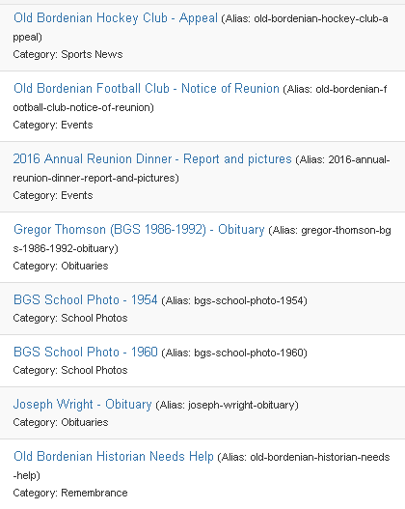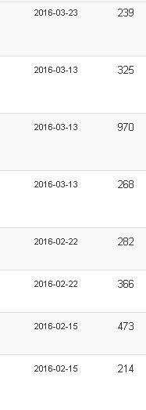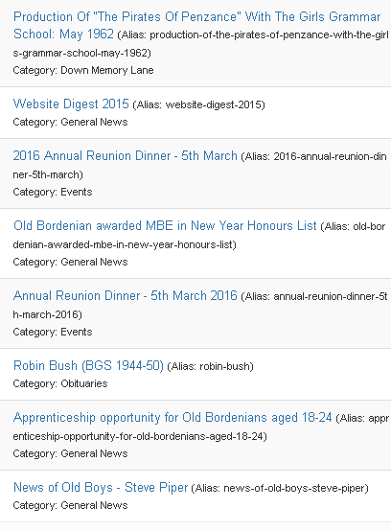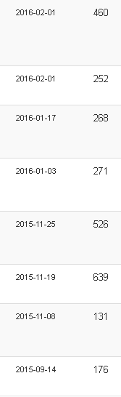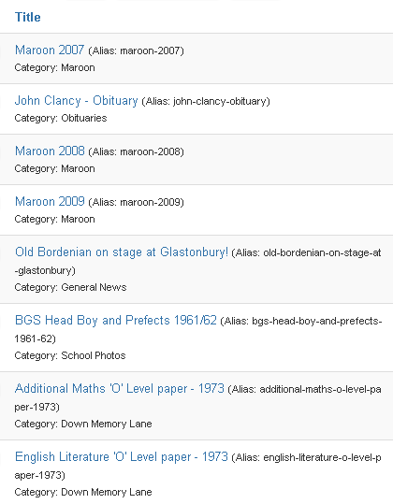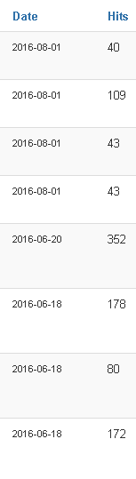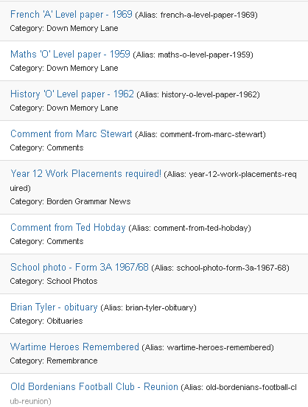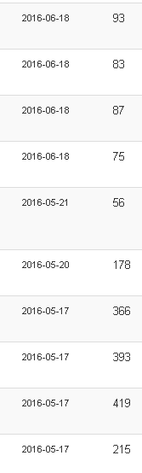

**Annex 2 - OBA Website posts – top 10 by number of hits to 28 August 2016**

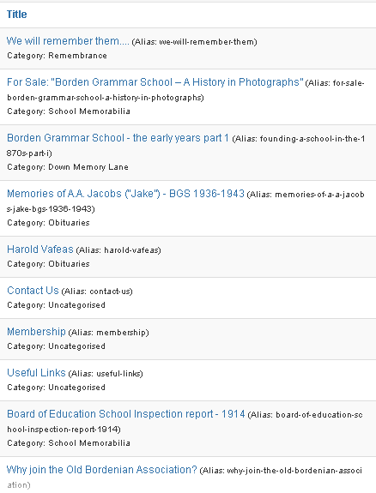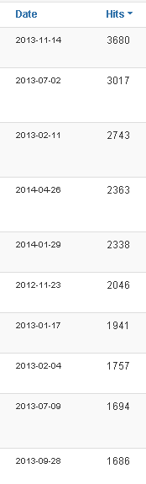

**Remembrance:** Peter Taylor and Chris Laming gave a brief report of their visit to Ypres with Graham Barnes on 6 May for the dedication of a memorial plaque at St George’s Memorial Church, to the OBs who gave their lives in the First World War. They had also paid their respects to the late OB Ken Sears, whose role as a trustee of the church is also recorded on a separate plaque at St George’s.

This year’s annual service of remembrance will take place at the school on Saturday 7 November. Neil Hancock is making the arrangements and organising the event.

**There being no further business the meeting closed at 8.34 pm.**

**Dinner report:** D. Palmer reported that arrangements are in hand for the annual dinner on 25 March but that help was needed due to his impending absence on the weekend of the event. P. Lusted said a combination of supporters (himself, A. Snelling and M. Pack) would work together to produce place cards and table plans and liaise with UK Paper.

The committee accepted an idea from Mike Pack that the dinner notice should contain an alert to the effect that unless dinner support increased, then the 2017 dinner may be the last.

P. Lusted agreed to approach Phil Bromwich to ask whether he might be prepared to speak. As an alternative there could be a combination of speakers from the football and hockey sections.

N. Hancock agreed to forward the names of regular attendees at the Sheppey Dinner in the hope that their attendance might boost numbers and it was also hoped that the success of a recent football section reunion might be repeated around the time of the 2017 dinner in a bid to attract support.

It was agreed that supporters of the hockey and football sections who were not actual members of the Association would be welcome to attend the dinner. K. Shea would seek to convert their attendance into membership on the night of the dinner if possible by giving out membership forms.

**Remembrance:** N. Hancock reported that the annual service of remembrance would take place at school on Saturday 12 November at 11.00 and it was hoped the committee would support the event. C. Laming would produce the order of service and Rev S. Evans had kindly agreed to officiate. M. Stewart would give a talk and would also invite family members of fallen old boys to attend.

**Any other business:** M. Stewart reminded the committee that as OB Governor he was able to raise any issues of concern with the governing body. He was warmly thanked for taking on the role.

D. Palmer raised an issue concerning the school archive and the process for obtaining information about the school when, as happens occasionally, committee members are approached via the website or the school office for information about former teachers or old boys. He said the lack of a proper school archive or archivist hindered the process and that there was no one to whom information requests could be referred. M. Stewart agreed to consider the issue with a view to raising the need to create a proper archive and archivist via the governing body.

There being no further business the meeting closed at 8.40 p.m.